**Reply to editors**

We thank the editorial board for the opportunity to revise our manuscript. Our responses to the editors’ comments are outlined below in regular font with editor/reviewer’s comments in bold font.

**Two reviewers have recommended revisions to your manuscript. Therefore, I invite you to respond to the reviewers' comments and revise your manuscript. Please remember that the reviewers' comments and the previous drafts of your manuscript will be published as supplementary information alongside the final version.**

**In addition to the above, please address the editorial requests towards the end of this letter**

**Editorial Requests:**

**- Please revise your title so that it includes your study design. This is the preferred format for the journal.**

We have included the study design in the title. It now reads:

*“Inequalities and deterioration in average lifespan among adults in Mexico, 1990-2015: A cross-sectional demographic cause-of-death analysis”*

**- Please include the study's sample size in the abstract.**

We study the national population of Mexico by sex, i.e. we do not work with a sample. However, we now state the size of the population of Mexico when the period of started and when it finished. The section of participants in the abstract now reads:

*“Aggregated national data (from 91.2 million people in 1995 to 119.9 million in 2015) grouped in**64 populations (32 Mexican-states* [including Mexico City] *by sex) with data on causes of death.*”

**- The first bullet point of the 'strengths and limitations' section is not a strength or limitation of the study. Please remove or revise. Each bullet point should relate to the methods and/ or design of the study.**

We have revised it and now the first bullet point is a strength of the paper:

*“We analyze nine cause-of-death groups using the concept of avoidable/amenable mortality that enables us to capture recent changes in mortality in Mexico.”*

**- Along with your revised manuscript, please provide a completed copy of the STROBE checklist (**<http://www.strobe-statement.org/>**).**

We have included a completed copy of the STROBE checklist

Thank you again for considering our manuscript.

José Manuel Aburto

Tim Riffe

Vladimir Canudas-Romo

**Reply to reviewers**

We appreciate the reviewers' comments; their detailed reading of the manuscript and suggestions that have greatly improved the article. Our responses to the reviewers’ comments are outlined below in regular font with reviewer’s comments in bold font.

**Reviewer: 1**

**Reviewer Name: Usama Bilal**

**Institution and Country: Urban Health Collaborative, Drexel Dornsife School of Public Health, Philadelphia, PA, USA Competing Interests: None declared**

**Inequalities in lifespan in Mexico, 1990 -2015: deterioration in adult survival (bmjopen-2018-022350) This is an interesting manuscript that aims to quantify the contribution of several causes of death to levels and changes in longevity in Mexican states from 1990 to 2015. The authors find an overall worsening in mortality, especially in men aged 15-49. The methodology is interesting, potentially replicable in other settings (especially with the provided GitHub repository), can provide a framework to analyze macro-level interventions in countries with within-country heterogeneity. I have a few comments that I hope can help improve the manuscript.**

**Introduction:**

**1. The introduction is clear, well written and concise. My main concern would be to have a clearer articulation of the objective of the paper. In particular, in P4 L14, it is unclear to me what “previous analyses” are. Are they those referred to in the previous paragraph? I think the authors can rephrase this paragraph to have a clear objective laid out.**

We thank the reviewer for his suggestion. To make clearer the specific objectives of the paper we followed his suggestion and rephrased the paragraph. In addition, we included the references that we refer to in the paragraph when saying “… complementing previous studies focusing on earlier years of the 21st century.”

It now reads:

“*The objective of this research is twofold. Firstly, analysing mortality trends by cause of death for all 32 Mexican states, by sex, and over the full period from 1990 to 2015. Thereby complementing previous studies focusing on earlier years of the 21st century.3,3-16 This choice of period covers several public health interventions and captures several major trends in state and cause-of-death variation. We further segment AM into health intervention-related and behavior-related AM causes that capture the epidemiological patterns of Mexico.14 Secondly, our work differentiates from earlier studies by comparing state mortality patterns with an easy-to-understand low-mortality benchmark calculated for large age groups (i.e. 0-14, 15-49 and 50-84). This concept has been previously used in mortality studies.17-19 Deviations from the low-mortality benchmark indicate a strong potential for improvement.”*

References

3. Canudas-Romo V, García-Guerrero VM, Echarri-Cánovas CJ. The stagnation of the Mexican male life expectancy in the first decade of the 21st century: the impact of homicides and diabetes mellitus. J Epidemiol Community Health 2015;69(1):28-34.

13. Dávila-Cervantes CA, Agudelo-Botero M. Mortalidad evitable en México y su contribución a los años de vida perdidos: Análisis por grado de marginación estatal, 2001-2010. Papeles de población 2014;20(82):267-86.

14. Aburto JM, Beltrán-Sánchez H, García-Guerrero VM, et al. Homicides in Mexico reversed life expectancy gains for men and slowed them for women, 2000–10. Health Affairs 2016;35(1):88-95.

15. Canudas-Romo V, Aburto JM, García-Guerrero VM, et al. Mexico's epidemic of violence and its public health significance on average length of life. Journal of epidemiology and community health 2017;71(2):188-93.

16. Gómez-Dantés H, Fullman N, Lamadrid-Figueroa H, et al. Dissonant health transition in the states of Mexico, 1990–2013: a systematic analysis for the Global Burden of Disease Study 2013. The Lancet 2016;388(10058):2386-402.

17. Whelpton PK, Eldridge HT, Seigel JS. Forecasts of the Population of the United States, 1945-1975: US Govt. Print. Off. 1948.

18. Wunsch G. A minimum life-table for Europe. European Demographic Information Bulletin 1975;5(1):2-10.

19. Vallin J, Meslé F. Minimum Mortality: A Predictor of Future Progress? Population-E 2008;63(04):557-90.

**Methods:**

**2. Ill-defined causes of death. The authors describe their classification of causes of death as including amenable causes (divided in 4 subgroups), diabetes, IHD, lung cancer, cirrhosis, homicides, road traffic accidents, and residual causes. The redistribution of ill-defined causes of death (all included in “Residual causes” here) is certainly a hot topic in global health, and the authors have decided not to redistribute them. While the merits of both approaches can be debated, the authors should at least include the reasoning behind their decision and the potential drawbacks of not redistributing these deaths.**

We thank the reviewer for his observation. Mexico is among the countries with high-quality data according with the Pan American Health Organization’s criteria. Underreported deaths are estimated to be around 0.8%, (WHO 2018, OPS 2014) while ill-defined causes of death represented 2.1% in the beginning of the century and has decreased to 1.7% more recently (OPS 2014).

It is true that redistributing deaths proportionally is common practice in cause-of-death analysis to have a complete set of mortality. In this sense, we decided two leave ill-defined causes in the ‘Residual category’ for two reasons. Firstly, we didn’t want to overestimate cause-specific effects when decomposing between state and the benchmark. This is because distributing them proportionally assumes that every cause has the same chance of being ill-defined, which is not necessarily true in Mexico, particularly with violence-related mortality. Secondly, given the low proportion of ill-defined causes in Mexico, the effect of ill-define being distributed would be negligible in overall AM categories and when decomposing.

References

World Health Organization. "Global health observatory data repository 2018." Available <http://apps.who.int/gho/data/node.imr.WHS10_9?lang=en> main A364 (2018).

Organización Mundial de la Salud. Organización Panamericana de la Salud. "Enfermedades transmisibles y análisis de salud/información y análisis de Salud: Situación de salud en las Américas: Indicadores Básicos 2013." (2014).

**3. Low-mortality benchmark. The authors use a low-mortality benchmark defined as the state with the lowest mortality in each age, year, cause and sex group. However, I worry that with some states being small (7 states had a population <1M in 2000), some of these low mortality benchmarks may be random deviations. Figure 1 shows how the low-mortality benchmark is very far away from the other states in the 50-84 age group. If I’m understanding Figure 3 right, that state is Zacatecas (lowest mortality), which is in the low end of population numbers. The authors do implement a smoothing technique, but there are very few measures of uncertainty in the figures (or appendix).**

We thank the reviewer for his comment. The smoothing techniques that we implement allow us to avoid random variations and age-heaping in death counts by sex, state and groups of causes of death. On the other hand, our low mortality benchmark is far from the states in most of the age-groups because it consists of the lowest mortality level observed in each, year and cause by sex -i.e. the benchmark can consist of a combination of values observed in different states. Figure 3 shows that the state achieving the longest average survival in 2010-15 (or lowest gap with benchmark) between ages 50 and 85 is Zacatecas, which is still far from the benchmark.

It is true that small population sizes could bias our results, and we thank the reviewer for this observation. As a robustness check, we calculated Confidence Intervals (95%) for all our estimates of temporary life expectancy, including the benchmark. We estimated them assuming deaths are Poisson distributed following Camarda (2012). The figure below shows state-specific temporary life expectancies for the young (0-14), young adults (15-49) and older adults (50-84) populations in 2000, 2010 and 2015 with confidence bands at the 95% level. The benchmark is at the top (highlighted in blue), and Baja California Sur, Colima and Campeche are highlighted in red. These last three had a population of less than 1 million in 2010 (INEGI, 2018).

The figure shows that for the young and young adults confidence intervals are very similar across states, including the benchmark. The CIs in these age groups are relatively narrow, even in those states with lower population. In the last age groups, however, CIs are systematically wider. This suggests more variation in ages at death between ages 50 and 84.

We added to the main manuscript in the methods section that we performed this robustness check and included the results in the supplementary material.

References

Camarda, C. G. (2012). MortalitySmooth: An R package for smoothing Poisson counts with P-splines. Journal of Statistical Software, 50(1), 1-24.

INEGI (2018) Population size by state in Mexico. Accessed 08/05/2018 .

<http://www.beta.inegi.org.mx/app/tabulados/pxweb/inicio.html?rxid=d518b312-a32e-4d23-a8dd-08a64c187a6c&db=Poblacion&px=poblacion_1>

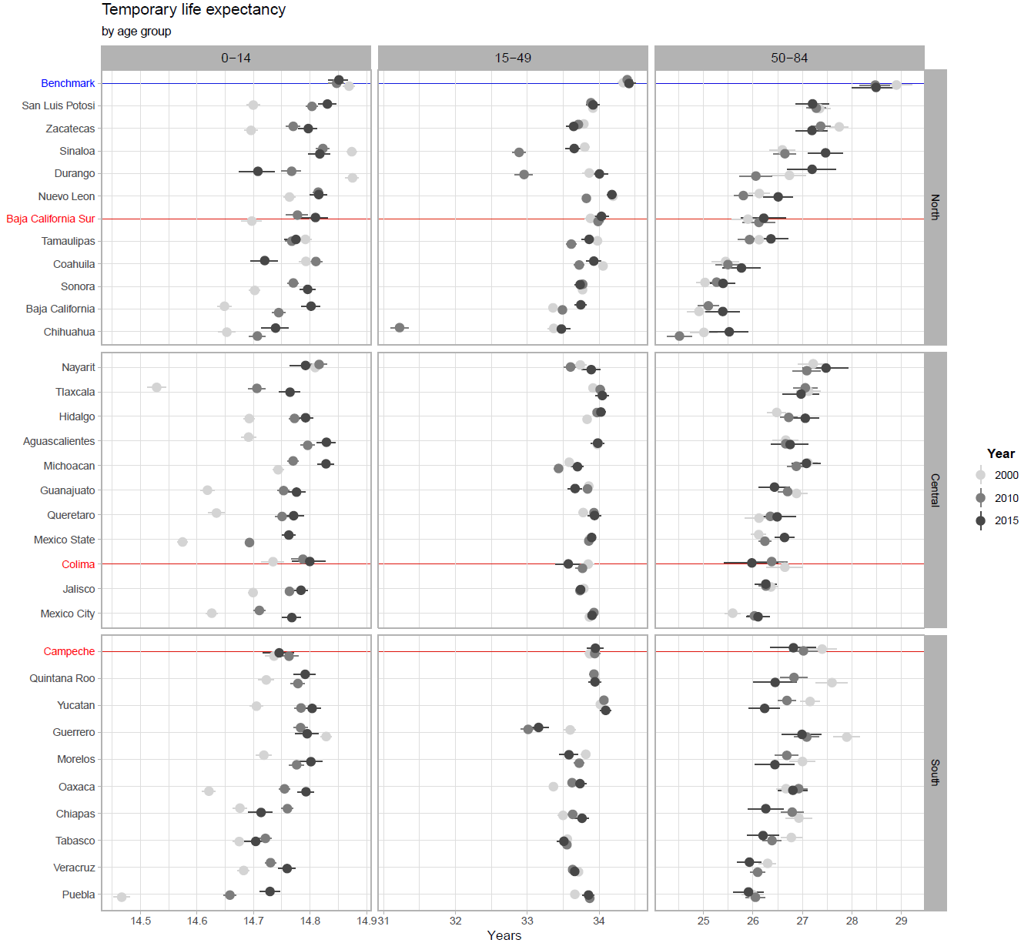

**4. Statistical methods: I have two concerns regarding lack of detail in this section. The authors say that “Period life tables […] were calculated following standard demographic methods” and reference the HMD protocol. However, in order to be able to replicate these results more details on specific methods used should be provided. The same issue applies to decomposition techniques. If this is too much detail for the manuscript, details can be included in the appendix.**

To be clearer about the methods. We did the following changes to the Methods section:

1. We added *“… To mitigate random variations over time and correct for age-heaping, these rates are adjusted in two step. First, we smooth cause-specific death counts over age and time for each state and sex separately using a 2-d p-spline..”*
2. Regarding the period life tables construction, we added the reference of a standard text book for demographic analysis (Preston et al 2000), that we followed, and specifically refer the reader to Chapter 3. In this reference, a concise explanation on how to construct and interpret a life table is provided.
3. Regarding how to calculate temporary life expectancy, we provide the main reference to the reader (Arriaga, 1984). In addition, a short description is provided in the supplemental material.
4. To better describe the decomposition method, we added the next sentences:

*“The decomposition method used in this analysis is based on a model of demographic functions that change gradually over time.33 It is a stepwise-based demographic method and has been successfully used to decompose age and cause-specific effects on life expectancy.34 We provide a short description in the Supplemental Material and the results are fully reproducible from the R-code provided in the Data Sharing statement.”*

1. In addition to the Github repository with the code and data (https://goo.gl/L9ppM9), we included a short description of the decomposition method in the appendix:

*The decomposition method used in this paper relies on a model of demographic functions based on continuous change (Horiuchi et al 2008). Suppose (e.g. temporary life expectancy between ages 15 and 49) is a differentiable function of covariates (e.g. each age-cause specific mortality rate) denoted by the vector . If we have observations of two populations and . We assume that that is a differentiable function between and , then the difference in between and can be expressed as follows:*

*where is the total change in (e.g. temporary life expectancy) produced by changes in the -th covariate, . The 's in equation (2) were computed with numerical integration following the algorithm suggested by Horiuchi et al (2008).*

References added

Preston, Samuel, Patrick Heuveline, and Michel Guillot. "Demography: measuring and modeling population processes." (2000).

Arriaga EE. Measuring and explaining the change in life expectancies. *Demography* 1984;21(1):83-96.

**Results:**

**5. The graphical representation of results is remarkable and clear.**

Thanks, all the graphs are reproducible by following the code made available on Github (https://goo.gl/L9ppM9).

**6. Figure 3 is a little bit hard to read. I’d suggest that the authors repeat the name of each state in each column, and join these names by lines (the same lines in the current figure). Otherwise, trying to figure out the ranking in ages 50-84 is very hard.**

We thank the reviewer for this suggestion. We followed his advice and produced the graph as he suggested. The outcome, which reads better than the original one, looks like:

**Discussion**

**7. Limitations: some of the aspects indicated in comments 2-3 above should be at least mentioned as limitations of this study.**

Thank you. We have now included sentences emphasizing the two issues in comments 2-3.

We added the next sentences to the Strengths and limitations section:

1. *In addition, underreported deaths and ill-defined causes of death could potentially bias our results. Mexico is among the countries with high-quality data according with the Pan American Health Organization’s criteria. Underreported deaths are estimated to be around 0.8%, (WHO 2018, OPS 2014) while ill-defined causes of death represented 2.1% in the beginning of the century and has decreased to 1.7% more recently (OPS 2014). Therefore, we expect our main findings to hold given the small percentages of ill-defined and underreported deaths.*
2. *Finally, small population sizes could bias our results. As a robustness check, we calculated Confidence Intervals (95%) for all our estimates of temporary life expectancy, including the benchmark (Supplementary material), and did not find major differences with our main results.*

**8. Conclusion: the last paragraph of the conclusion seems very speculative. In particular, given that the authors spend a lot of effort in describing results by homicides and their prevention, it is unclear how the encouragement of “physical and healthy activities” fits into the results of this study.**

We thank the reviewer for his suggestion. We rephrased the last sentence to make clear the role of physical and healthy activities, and highlighted the need of new policies to mitigate violence in Mexico. It now reads:

*“As many developing countries, Mexico will have to face these new challenges with a broad strategy. This should include a continuous and adaptable health system ready for the current and future health adversities at the physical, mental and societal levels. Many other institutions will also have to coevolve including importantly the development of an education system that embraces and encourages physical and healthy activities to diminish risk factors that contribute to the high prevalence of obesity and cirrhosis in Mexico. Finally, the burden of violence in recent years demonstrates the failure of current policies trying to mitigate violence in the country. New strategies that replace current ones are needed and embracing evidence based policies (e.g. drug policies) could be a new venue to eradicate the consequences of violence on the Mexican population.”*

**Reviewer: 3**

**Reviewer Name: Sally C Curtin**

**Institution and Country: National Center for Health Statistics/CDC, USA Competing Interests: None declared.**

**I think this is a very well-written, well-executed article. My primary concern is whether suicide is adequately dealt with, especially in the young adult population. It is lumped in with "other causes" in the analyses but the graph in figure 1 shows that it increased nearly steadily over the period. In the US, suicide is the 2nd or 3rd leading cause of death among young adults. So my question is whether some of the deterioration in survival for young adults is due to suicide as well as homicide. I know that suicide is not as much of an issue in Mexico as in the US, but I think that suicide should be directly discussed. In the US, suicide is one of the causes of death that has lead to a slight decline in life expectancy (see Kochanek et al, Mortality in the United States, 2016). Suicide may also be an issue with the older adults, but other natural causes are much more prominent there than for the younger adults. While I think that the article is quite strong, discussing suicide more fully would strengthen it even more.**

We thank the Reviewer for her careful reading and suggestions that helped improving the cause-of-death analysis of the paper. In this regard, it is true that suicide in Mexico is becoming a relevant public health issue. It has been increasing since the 1990s (Figure 1 in the supplementary material) and just few studies have focused on suicide mortality. Although, among males, higher mortality of accidents and homicides mostly explain mortality trends recently, suicide is a cause of death that should receive more attention. Therefore, we followed her suggestion and included suicide in the set of causes that we look independently within our concept of Avoidable/Amenable mortality. We found the following results:

Figure 1 shows the contribution of suicide mortality to the gap between each state with the benchmark. The color scale goes from 0 to the largest observed in the country (around 2.8 years by homicide mortality in Chihuahua in 2010-2011). The contribution of suicide, even though has increased over the years (more than 6,000 deaths in 2015), is below three months in almost every state in the three age groups for males. This could be due to the small proportion representing in overall mortality. For example, in 2015 655.7 thousand deaths were registered (INEGI, 2018), this means that suicides represent less than 1% of the total mortality. Secondly, if suicide mortality is similar in all states, then the contribution to the benchmark would also be very small because of the close values of suicide mortality. However, particularly in states in the South, they do explain around one quarter of year with the benchmark. We chose to include this analysis in the supplementary material for the interested reader. For visualization purposes, since our graphs are already dense, we do not include the negligible effects of suicide in the figures in the paper and include suicide in the ‘residual’ category. Nevertheless, in addition to including suicide in the cause-of-death classification and looked at it independently, we acknowledge the increase in suicide mortality and call for further research in the discussion section.

We did the next changes to the manuscript:

1. In the section of Data sources & Methods we included suicide in the classification of causes of death:

*“…Likewise, we separate homicide, suicide and road traffic accidents because they have emerged as leading causes of death among young people, and the first one recently had a sizeable impact on life expectancy in Mexico.”*

1. In the discussion section, we added the next sentences and references:

*“… the exposure that people have had to violence has triggered mental health problems, e.g. population perceived vulnerability (Canudas-Romo et al. 2016). At the same time suicide is strongly linked to mental disorders (*Zalsman *et al 2016). Thus, if the Mexican health system does not have proper interventions to handle the mental health needs of the population, an increase in suicides might be observed in the future.”*

*References*

Zalsman, G., Hawton, K., Wasserman, D., van Heeringen, K., Arensman, E., Sarchiapone, M., ... & Purebl, G. (2016). Suicide prevention strategies revisited: 10-year systematic review. The Lancet Psychiatry, 3(7), 646-659.

Canudas-Romo, V., Aburto, J. M., García-Guerrero, V. M., & Beltrán-Sánchez, H. (2016). Mexico's epidemic of violence and its public health significance on average length of life. J Epidemiol Community Health, jech-2015.

1. In the supplementary file, we included a subcategory with ICD 9 (E950-E959) and 10 (U03, X60-X84, Y87.0) codes for suicide and self-inflicted injuries.
2. In the supplementary file, we included a short description and the results described here.

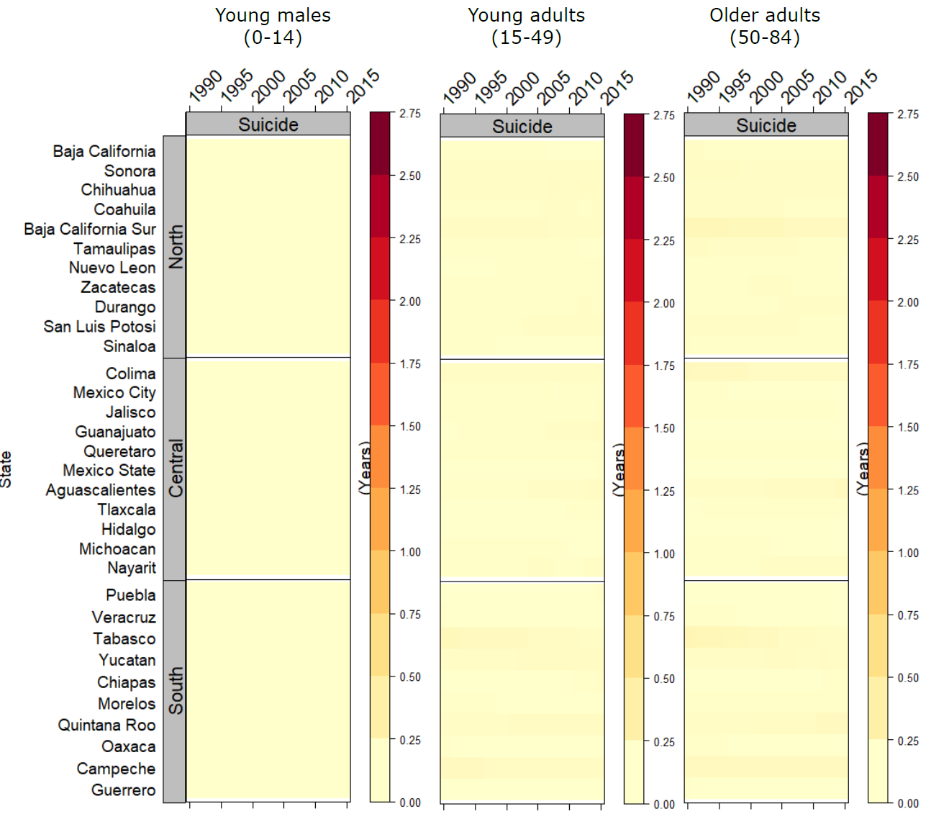

Figure 1 Contribution of suicide to gap with benchmark survival by age-group for males.